Zapraszam do śpiewania piosenki, dzieci znają dwie pierwsze zwrotki, poniżej słownictwo oraz tekst piosenki. W filmiku są również słowa piosenki. Miłego śpiewania
https://www.youtube.com/watch?v=l4WNrvVjiTw
Happy – szczęśliwy
Angry – zły
Scared – przestraszony
Sleepy – senny

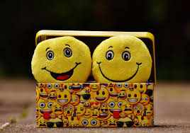 | Happy
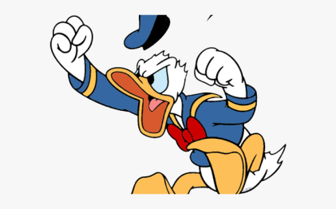 | Angry
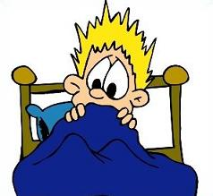 | Scared
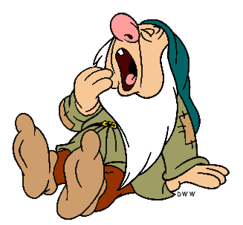 | Sleepy

Tekst piosenki:
If you're happy happy happy clap your hands.
If you're happy happy happy clap your hands.
If you're happy happy happy
clap your hands, clap your hands.
If you're happy happy happy clap your hands.
If you're angry angry angry stomp your feet.
If you're angry angry angry stomp your feet.
If you're angry angry angry
stomp your feet, stomp your feet.
If you're angry angry angry stomp your feet.
If you're scared scared scared say, "Oh no!"
If you're scared scared scared say, "Oh no!"
If you're scared scared scared say,
"Oh no!" Say, "Oh no!"
If you're scared scared scared say, "Oh no!"
If you're sleepy sleepy sleepy take a nap.
If you're sleepy sleepy sleepy take a nap.
If you're sleepy sleepy sleepy
take a nap, take a nap.
If you're sleepy sleepy sleepy take a nap.
If you're happy happy happy clap your hands.
If you're happy happy happy clap your hands.
If you're happy happy happy
clap your hands, clap your hands.
If you're happy happy happy clap your hands.

