Dzień dobry. Poniżej znajduje się link do tematu części ciała:
https://www.youtube.com/watch?v=RuqvGiZi0qg

 | Head (głowa)
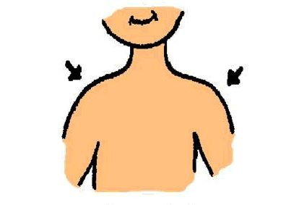 | Shoulders (ramiona)
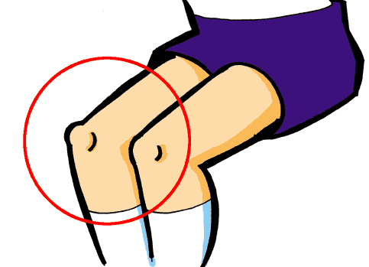 | Knees (kolana)
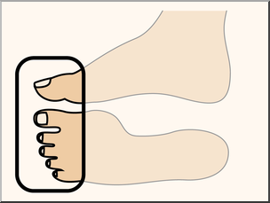 | Toes (palce u stóp)
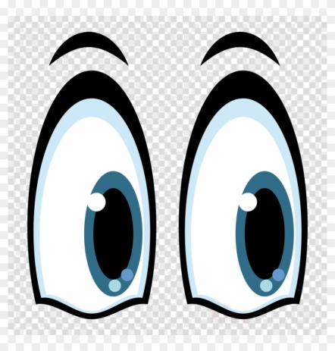 | Eyes (oczy)
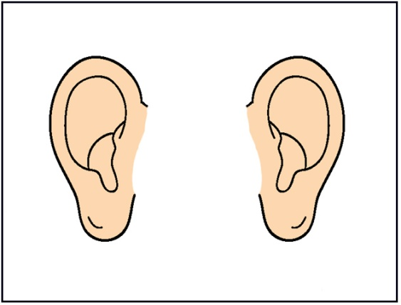 | Ears (uszy)
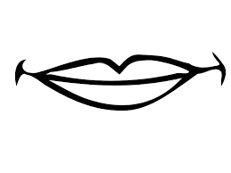 | Mouth (usta)
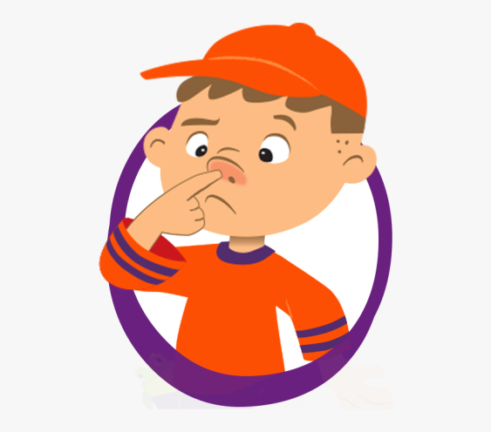 | Nose (nos)

Tekst piosenki:
Head, shoulders, knees, and toes, knees and toes.
Head, shoulders, knees, and toes, knees and toes.
And eyes and ears and mouth and nose.
Head, shoulders, knees, and toes, knees and toes.

Head, shoulders, knees, and toes, knees and toes.
Head, shoulders, knees, and toes, knees and toes.
And eyes and ears and mouth and nose.
Head, shoulders, knees, and toes, knees and toes.

Head, shoulders, knees, and toes, knees and toes.
Head, shoulders, knees, and toes, knees and toes.
And eyes and ears and mouth and nose.
Head, shoulders, knees, and toes, knees and toes.

Head, shoulders, knees, and toes, knees and toes.
Head, shoulders, knees, and toes, knees and toes.
And eyes and ears and mouth and nose.
Head, shoulders, knees, and toes, knees and toes.

